**Purposive Communication**

**Knowledge**

1. Describe the nature, elements and functions of verbal and non-verbal communication in various and multi- cultural contexts
2. Explain how cultural and global issues affect communication
3. Determine culturally appropriate terms, expressions and images
4. Evaluate multimodal texts critically to enhance receptive (listening, reading, viewing) skills
5. Summarize the principles of academic text structure

**Skills**

1. Convey ideas through oral, audio-visual and/or web-based presentation for different target audiences in local and global settings using appropriate registers
2. Create clear, coherent and effective communication materials
3. Present ideas persuasively using appropriate language registers, tone, facial expressions and gestures
4. Write hid present academic papers using appropriate tone, style, conventions and reference styles

**VALUES:**

1. Adopt cultural and intercultural awareness and sensitivity in communication of ideas
2. Appreciate the differences of the varieties of spoken and written language
3. Adopt awareness of audience and context in presenting ideas
4. Appreciate the impact of communication on society and the world.

**COMMUNICATION**

* COMMUNICATION IS A PROCESS OF USING MESSAGES TO GENERATE MEANING.
* (PEARSON ET AL)
* COMMUNICATION IS SYSTEMATIC PROCESS IN WHICH PEOPLE INTERACT WITH THROUGH SYMBOLS TO CREATE AND INTERPRET MEANINGS**.**
* Communication is the process of sending information to oneself or another entity, usually via language
* Broadly speaking, and information, communication is a process of sharing opinions, ideas and feelings.

Jimenez and Alparo

* Communication is the process of sending and receiving messages sometimes through spoken or written words and sometimes, non-verbally words through facial expressions, gestures and voice qualities.

ELEMENTS OF COMMUNICATION

* 1.People
* 2.Message
* 3.Channel
* 4.Feedback
* 5.Code
* 6.Encoding and Decoding

Encoding-is the process of translating an idea or a thought into a code.

Decoding- the process of assigning meaning to an idea

* 7.Noise or Barrier-refers to interference in the encoding and decoding processes which affect the clarity and understanding of a message.

Communication Process

* 1.TRANSACTIONAL
* 2.INEVITABLE
* 3.GOAL-ORIENTED
* 4.HAS VARIOUS LEVELS
* 5.COMPLEX
* 6.CAN BE LEARNED
* 7.RELATIONAL
* 8.GUIDED BY CULTURE

**ETHICS**

1.COMMUNICATORS ARE HONEST.

**2.**ETHICAL COMMUNICATORS ARE AWARE OF THE CONSEQUENCE OF THE THOUGHTS AND ACTIONS

3.RESPECT OTHERS OPINIONS

4. JUST AND FAIR.

**MULTICULURAL SETTINGS**

COMMUNICATION CONTEXTS

**Context-**surroundings,circumtances,environment, background

1.**Personal Context**- involves the background of both the sender and receiver of the message.

* Religion,marital status,socio-economic status.

2.**Physical Context**-pertains to the environment where communication takes place.

3.**Social Context**-refers to the kind of relationship that exists between the sender and the receiver.

4.**Psychological Context**—the emotions and feelings of the participants in the communication process.

**COMMUNICATION AND GLOBALIZATION**

**MEDIATED COMMUNICATION**

1. 1.Text messaging
2. 2.Video calling/conferencing
3. 3.Emailing
4. 4.Chatting online
5. 5.Posting on social media

**Globalization**

**GLOBALIZATION**-is a term that implies the growth of economic and cultural assimilation and interconnectedness of different cultures which result in the integration of people across the globe.

**DIVERSITY**-(pagkakaiba-iba) the concept that endures respect, acceptance, and understanding. It recognizes that people are unique from each other with respect to their age, gender, race, ethnicity, culture, socio-economic status, educational background and ideologies.

**Views on technological advances**

Parents have complained that talking to their children

have become difficult.

Why?

Effects

As effective communicator, one must be aware Of these issues. You should be able to make informed decisions and influence other people to be ethical and responsible in the use of technology which should serve as a platform to celebrate and respect diversity

## MODULE 3 & 4

MAJOR CHARACTERISTICS AND RESEARCH APPROACHES OF QL

**MAJOR CHARACTERISTICS of QLR**

**THEORETICAL BASES( Yap-Aizon, 2005):**

1. theory of a dark room

2. theory of Pearl in the Ocean

**FEATURES:**

1. Qualitative data are collected in form of words or pictures rather than numbers

2. Narrative descriptions and narrative summary of results

3. Assessment of validity is through cross –checking sources of information

4. Uses expert informant ( purposive sampling)

|  |  |  |
| --- | --- | --- |
| **CRITERIA** | **Quantitative Research(QN)** | **Qualitative(QL)** |
| * Scientific method | Test hypothesis and theory  Explanatory Objective Numbers  statistical relationships  Statistical Reports | Generate hypothesis and theory |
| * Common research objective | Exploratory |
| * Nature of reality | Socially constructed |
| * Nature of data | Words |
| * Data analysis * Form of final Report | Search for themes, patterns, holism |
|  | Narrative report |

► ROAD MAP FOR CONDUCTING LITERATURE REVIEW

► A. Instruction

Review of Literature involves systematic identification, location, and analysis of materials related to the research problem:

Books, book chapters , articles , abstracts, reviews , monographs, dissertations, research reports, electronic media

Literature Review involves locating and assimilating what is already known, then as a researcher, you enter from a critical and creative standpoint.

- Allows to acquire a full understanding of the topic,

- what has been said about it,

- how ideas related to topic have been researched , applied and developed.;

- key issues surrounding the topic ,

- main criticism that are made regarding work on the topic.

**► REVIEW….CONT.**

Concept mapping

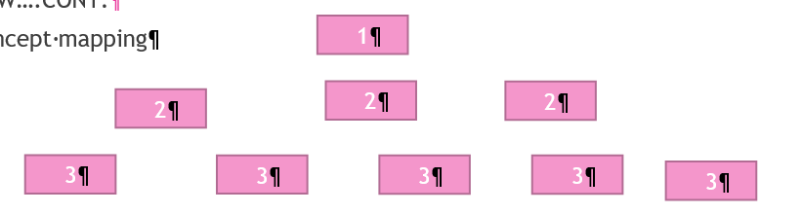

**Template for Analysis of research-Based Literture**

Study details: Author, date publication

Research sample findings

**Conceptual Framework**: set of interrelated ideas, impose meaning.can be displayed or summarized as schematic diagram, mind maps, flow chart, tree diagram

► It a detailed narrative form

► Theoretical Framework : relation among related concepts and assumptions

**B. APPLICATION**

Focus on specific problem or outline: provide a statement of purpose, identifies the bodies of literature , provide rationale for the topic selected, present the review of each topic, present the conceptual framework, provide summary of literature review and implication for the study

**GENERAL CHARACTERISTICS:**

-Naturalistic inquiry( study real worl situations as they unfold naturally/ non-manipulative/ non-controlling/ openness to whatever emerges)

-Inductive analysis ( immersion in the details and specifics of the data to discover important categories dimensions and interrelationships)

-Detailed thick descriptions inquiry in-depth, direct close to quotations capturing people’s personal perspective and experiences

**Cont….**

► Personal Contact and Insight( researcher has direct contact with and get close to the people, situation and phenomenon under study)

► Unique case orientation, assumes that each case is unique and special

► Design Flexibility ( open to adapting inquiry as understanding deepens of situation chnges

**STEPS IN THE CONDUCT OF QUALITATIVE RESEARCH**

► 1. Identification of phenomenon to be studied. Start with a foreshadowed problem which is not restrictive or limiting / its purpose is to provide direction.

► 2. Identification of the participants in the study. ( Sampling is always purposive)

► 3. Generation of hypotheses( hypotheses are not posed at the beginning of the study but emerge from the data as the study progresses

Step..cont.

► 4. Data Collection( No treatment or manipulation of data/ researcher is continually observing people, events and occurrences/ interviewing

/ examining documents and records)

► 5. Data Analysis ( Synthesizing information obtained from several sources. Analysis relies heavily on description.

► 6. Drawing conclusion. Conclusion are drawn continuously throughout the course of the study.

**PRESENTING RESEARCH METHODOLOGIES AND APPROACHES of QLR**

**METHODOLOGY**

Refers to how research proceeds and encompasses a range of logistical, relational, ethical and credibility issues.

METHODS

Commonly denotes specific techniques, procedure or tools used by the researcher to generate and analyze data.

Appropriateness of instruments you have chosen for your study, making use of the literature to support each of your choices. It is not a run down discussion of data gathering procedure.

**SEQUENTIAL STEPS COVERED INMETHODS OF DATA COLLECTION**

1. Describe each data collection method used.

2. Provide a rationale for each of the method used.

3. Provide complete information about how you used each method.

4. Describe how you develop each of your instruments.

5. Describe how you field tested your instrument.

6. Describe how you recorded and safe guarded your data.

7. Describe the steps you took to preserve confidentiality and anonymity of data

**Previous**:

► Chapter 1: THE PROBLEM AND ITS BACKGROUND

► Chapter 2: LITERATURE REVIEW AND CONCEPTUAL FRAMEWORK

► Chapter 3: RESEARCH METHODOLOGY

► Chapter 4: RESULTS, ANALYSES AND INTERPRETATION

► Chapter 5: SUMMARY, CONCLUSIONS AND RECOMMENDATIONS Proposal:

IMRAD = INTRODUCTION,METHODOLOGY ,RESULTS AND DISCUSSION

In a proposal =you project “what you will do”.

In a dissertation= you report in “what you have already done”. Write after the facts.past tense.

**Institutional Format: IMRAD**

**I** = INTRODUCTION

**M** = METHODOLOGY

**R** = RESULT

**A** = And

**D** = DISCUSSION

Relate your study to those issues and discourse( how you have gone through designing and conducting your study, while draw supporting evidence from literature from choices and decisions made

**ROAD MAP FOR DEVELOPING QUALITATIVE TECHNIQUES /APPROACHES(Bloomberg,et.al,2012)**

1. Observation

2. Interview

3. Documentary data /review / Content Analysis

4. Focus Group Discussion /Group Interview

5. Critical incidents

**PRESENTING RESEARCH METHODOLOGIES AND APPROACHES of QLR**

TECHNIQUES USED BY QUALITATIVE RESEARCHERS

**1.OBSERVATION**

**Roles of an Observer:**

1. Complete participant (researcher’s identity is not known to any of the individuals being observed / interact with the members of the group‘s as naturally as possible/ becomes one of them)

2. Participant as Observer.( Participates full in the activities of the group being studied but also makes it clear that he/she is doing research)

**Observation….cont**

3. Observer as Participant ( Participates superficially in the activities of the group being studied and makes it clear that is doing a research)

4. Complete researcher ( Observes activities of the group without becoming a participant in those activities)

**It is important to collect information about people, because people do not do what they say they do.**

**Observation** . Unobtrusive watching of behavioral patterns of people in certain situation to obtain information about the phenomenon of interest.

1. Laboratory Observation. Carried out in a setting that are set by the researcher inside the confines of research laboratory.

2. Naturalistic Observation . Is carried out in the real world setting **Qualitative Observation. Involves observing potentially relevant phenomena Types: Descriptive , Inferential, Evaluative**

1. Descriptive. It requires no inference making on the part of the researcher. You see something and write it down.

2. Inferential. It requires the researcher to make inferences about what is

observed and the underlying emotion. For example, you may observe wife banging pans and pots. From this observation you may assume (correctly) that she is frustrated with husband’s philandering ways.

3. Evaluative. It requires the researcher to make an inference and a

judgment from the behavior. For example, you may question whether angry wives have a positive relationship with dented pots and pans.

**INTERMISSION** : “Pinoy never tama ang sagot, kahit maayos ang tanong”

**( Pinoy never give right answer to a right question)**

Q1: Kumain ka na ba? A: Busog pa po ako

( Have you eaten?) ( I’m still full!)

Q2: Magkano ito? A: Mura lang

( How much is this?) ( It is so cheap.)

Q3: Saan kayo galing? A: Lumabas lang kami!

( Where have you been?) ( We went out)

Q4: Bakit wala ka kahapon? A: Absent ako!

( Why were you not around yesterday afternoon?) ( I was absent)

Q5: Anong oras na? A: Maaga pa!

(What time is it?) ( Too early!)

Q6: Saan ninyo gusto kumain? A:Kayo!

( Where do you want to eat?) ( Up to you!

**PHENOMENON: A security guard on the night shift**

After he sat down at 21:00, he began to drink coffee and greeted each delivery person cordially. Within an hour, a total of 6 delivery personnel had conversations with the guards, which lasted two to three minutes on average. Among them, the guards seem to prefer company A’s delivery staff over company B particularly. Because he will ask to see the ID of the delivery staff of Company B and ask them to park their motorcycles before they can go upstairs to deliver meals. Even the guards greeted each delivery member of Company A cordially. After drinking the coffee, the guard began to use the mobile phone. About every half an hour, he took the initiative to look up at the surveillance screen. In general, guards sit in their seats most of the time before leaving work at midnight unless the delivery person enters the building. The guard never seemed to have seen any resident after 21:00. He only needed to talk to the delivery person or occasionally look at the monitor screen while doing his own thing the rest of the time.

**OBSERVATIONAL VARIABLES**

1. **The physical setting**: What is the physical environment like? What is the context? What kinds of behavior is the setting designed for? How is space allocated? What objects, resources, technologies are in the setting?

2. **The participants**: Describe who is in the scene, how many people, and their roles. What brings these people together? Who is allowed here? Who is not here that you would expect to be here? What are the relevant characteristics of the participants? Further, what are the ways in which the people in this setting organize themselves?

3. **Activities and interactions**: What is going on? Is there a definable sequence of activities? How do the people interact with the activity and with one another? How

are people and activities connected? What norms or rules structure the activities and interactions? When did the activity begin? How long does it last? Is it a typical activity, or unusual?

4. **Conversation**: What is the content of conversations in this setting? Who speaks to whom? Who listens?

5. **Subtle factors**: , indicating a thinking process : Example: The security guard cordially, or a mother beaming and humming a bar or two of a favorite lyrics at her child while preparing child

6. **Your own behavior**: I am just a mere observer and not in any way participating in the situation. Just waiting and observing as the situation unfolds and come to a

Finish

**2. INTERVIEWING**

**Features**

1. Checking the accuracy of the impressions the researcher has gained through observation.

2. This is the most important data collection technique in qualitative research( Fetterman)

3. Finds out what is on the people’s mind ( what they think and how they feel about something)- because researchers cannot observe feelings, thoughts and intentions.

**Fundamental types of research interviews:**

1. **Structured**. Is essentially, verbally administered questionnaires, in which a list of predetermined questions are asked, with little or no variation and with no scope for follow-up questions to responses that warrant further elaboration.

2. **Semi-structured interview**. It is relatively quick and easy to administer and may be of particular use if clarification of certain questions are required. However, by their very nature, they only allow for limited participant responses and are, therefore, of little use

3. **Unstructured interviews**. Is reflective of any preconceived theories or theories or ideas and are performed with little or no organization then progress upon the initial response. They are time consuming, lack of predetermined questions

**Example**: Can you tell me about your experience of in a defense?

**TYPES OF INTERVIEW QUESTIONS**

1. Background/demographic questions.

Q: Ipakilala mo ang iyong sarili.

( Introduce yourself)

2. Knowledge questions( factual information)

Q:Paano ka nakapasok sa______?

Q: Maari ka bang maglahad ng mga naalala mong kararanasan noong ikaw ay bata pa?

3. Experience or Behavior question( find out what informant is currently doing)

Q: Sa ngayon,masasabi mo pang fulfilled na an iyong buhay? ,Maari bang ilarawan mo and buhay mo ngayon?

5. Opinions / values questions( find out what people think about the issue)

Q : Sa paanong paraan ka naiiba sa ibang kabataan?

( In what way are you different from today’s youth?

Q: Sa iyong, pagninilay, ano kaya ang kalagayan mo ngayon kung wala ang programa na iyon ?

6. Feelings questions( find out how informant feels about things}

Q: Galit ka ba sa mundo o galit ka sa buhay?

Q: Maliban doon, ano pa ang masasaya mong karanasan na naalaala bilang student assistant?

7. Sensory questions( find out what respondents has seen, heard, touched)

Q: Ano ang nararamdaman mo kung nakikita mo ang ibang bata kasing edad mo na pumasok sa eskwela?

**3. DOCUMENTARY DATA/CONTENT ANALYSIS**

These are analyses of the written or visual contents of a document. The purpose of which is to analyze the people’s conscious beliefs, attitudes, values, and ideas which are often revealed in the documents they produce.

**-textbooks**

- Essays/ poems/short stories/novels,etc.

- Newspapers

**-Magazine articles**

- Political speeches

- cookbooks

- advertisements

**-pictures**

- any type of written or visual communication

**4. SUMMATIVE FOCUS GROUP / FOCUS GROUP DISCUSSION(FGD)**

► Otherwise known as “Group interview”.” formative group interview”

► It is essentially a group discussion focused on a single theme ( Kreuger & Casey,2000).

► It possess elements of both participant observation and individual interviews, while maintaining their uniqueness as distinctive as a research method.

► On the part of the researcher, without strong facilitation skill, might result in “groupthink”.

► Purpose:1) augment the information obtained ;b)to provide additional data to ensure trustworthiness and credibility

**5. CRITICAL INCIDENTS REPORT.**

► A data collection method formulated (by Flannagan ,1954 in Bloomberg,2012)

► Intended to corroborate, say, an interview data,as supportive evidence.

**Example:**

Reflecting on your time that you have enrolled in your doctorate program, please recall one particular occasion while working on your dissertation that you felt frustrated or ill prepared

In 1-2 paragraph describe your experience:

* What were you trying to achieve?

* What were you thinking you should /could do to move forward?

**PROCEDURE FOR CHECKING AND RELIABILITY(Fraenkel and Wallen)**

1. Triangulation. Using variety of instrument, sources, methods to collect data.(Cross-checking)

2. There should be no discrepancies in description. Check respondents’ description of something against another.

3. Write down questions you ask.

4. Document sources of remarks whenever possible and appropriate.

5. Intersubjective validity (in phenomenology)

6. Using FGD,

7. Prolonged engagement –lengthy and intensive contact with phenomena(respondents)

8. Persistent observation. In depth pursuit of those with salient engagement

9. Peer debriefing. Exposing oneself to a disinterested professional peer.

10.Member checking. Continuous testing of information.

11. Thick descriptive data. Review on the narrative of description about a context or judgment about degree of fit or similarity that maybe made by others Who may wish to apply all or part of findings elsewhere.

12. External Audit. Auditing the process (dependability) , auditing the product( confirmability)

**MODULE 5:**

**QUALITATIVE DATA ANALYSIS**

**A. PROCESS OF DATA ANALYSIS (SARANTAKOS,1993)**

1. **DATA REDUCTION**. Process of manipulating , integrating , transformin g, and highlighting the data while they are presented. It is similar to summarizing, coding and categorizing . Involves careful reading of materials, identification of the main themes .

2. **DATA ORGANIZATION**. Process of assembling information around certain themes and points, categorizing information in more specific terms and presenting results in some forms.

3. **DATA INTERPRETATION**. Process of making decisions and drawing conclusions related to the research questions . Identifying the pattern and regularities, discoveries trends and explanations are respects of this process.

COMMUNICATION CONTEXTS

**CONTEXT-**surroundings,circumtances,environment, background

1.PERSONAL CONTEXT- involves the background of both the sender and receiver of the message.

* Religion,marital status,socio-economic status.

2.Physical Context-pertains to the environment where communication takes place.

3.Social Context-refers to the kind of relationship that exists between the sender and the receiver.

4.PSYCHOLOGICAL CONTEXT—the emotions and feelings of the participants in the communication process.

* Opinions, judgments, prejudices,( an adverse of opinion) attitudes
* ex. break up
* It is important to recognize one’s mood.

5.CULTURAL CONTEXT-vital in communication. Includes set of beliefs,value systems,guiding principles, and assumptions based on oné’s race, age,gender.

**Cultural Dimensions**

1.Individualism from collectivism

Individulistic culture puts premium on the self and fulfillment.

Collectivist culture values teamwork and collaboration.

2.Context which has two categories.

Low-context culture views explicit words as way to convey messages.

High –Context Culture uses subtle non-verbal behaviors and implicit information to convey meaning.

3.Chronemics pertains to the concept of time among cultures.

* Monochronic Culture advocates(,counsel,intecessor ) punctuality,timely completion of tasks,and accomplishment of one task at a time. Schedule matters in this dimension.

4.Uncertainty avoidances refers to the need to foresee what is going onto happen.

* Low-uncertainty avoidance culture is tolerant of unpredictable and uncontrollable situations.
* -maintains few rules and allows spontaneity of responses to situations.
* High –uncertainty avoidance culture values precision and always attempts to anticipate risks to possibly reduce them.

5.Extent to how the equality or inequality of power is accepted of expected referred as **power distance.**

**Low-power distance culture** values equal distribution of power**.**

**High-power Distance culture**- recognizes that unequal distribution of power.

6.Gender-masculinity or femininity.

Masculines cultures advocate for strict adherence to conventional gender roles and behaviors.

Masculine roles are more valued than feminine.

Mexico,Italy ,Japan

Feminine Cultures are based on the premise that men and women assume varieties of roles ,both valued regardless of sex and gender,

.

Sweden,Denmark,and Norway

7.Long-term or short term orientation refers to how patience is valued in waiting outcomes of actions. By being very performance driven.

* Short-term orientation culture is characterized by being very performance driven.It emphasizes quick results. USA,Pakistan,Russia
* Long-term Orientation culture- is more laid back that it has more patience in waiting for outcomes of action.
* Japan,China, Hongkong ,Taiwan

* Communication is not just confined to speaking

COMMUNICATION THROUGH VERBAL AND NON-VERBAL MESSAGES

Verbal Communication uses spoken or written words to communicate a message.

Listening is an important skill .

Non-verbal Communication is the use of body language, gestures, facial expressions, posture

LANGUAGE is a set of arbitrary symbols which create possible combination used

Language register refers to the and style of spoken and written discourse

**Verbal and non-verbal communication**

**Verbal communication** uses spoken or written words.

Speaking, Listening is an iMPORTANT skill in communication

**Language is a is set of arbitrary symbols in which create possible combination of utterances primarily used for communication**

Language is a is set of arbitrary symbols in which create possible combination of utterances primarily used for communication

Language register refers to the level and style of spoken and written discourse

**Three types of language register**

1. **Formal** is used by professional context. It is highly structured, impersonal and more serious in tone
2. **Informal-** is casual, personal and more intimate in its tone and choice of words.
3. **Neutral-** more factual and non emotional type of language register ,it is used highly in business oriented and technical contexts**.**

**Language Register**

**Formal**

* Business Letters - Conferences
* Letters of Complaint -Public Forums
* Academic Essays
* Official Speeches
* Announcements
* Professional Emails
* Job interviews
* Business Meetings

**INFORMAL**

* Personal Emails - coffee table sessions
* Text Messages
* Short notes
* Friendly letters
* Most blogs
* Diaries
* Chatting
* Parties

**NEUTRAL**

* Reviews
* Articles
* Some letters
* Some essays
* Technical writings
* Business presentations
* International conferences

**Non-verbal communication**

Refer to the cues sent through body language, posture, gestures, movements, facial expressions and appearance that are used in place of or simultaneously with verbal messages.

**Category of non-verbal communication**

1.**KINESICS**-includes gestures, posture, eye contact, facial expression and touch.

2.**Paralanguage**- use of Voice

Voice should be intelligibility, variety and understable patterns.

Pertains to the loudness of the voice, rate of your speech, pronunciation, enunciation ( to make a definite or systematic statement. )

4.**CHRONEMICS** –use of time

-how people perceive and value time

**CONVEYING MESSAGES THROUGH WRITTEN COMMUNICATION**

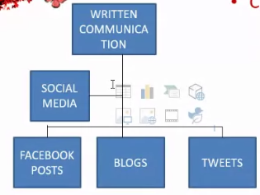

1. ln which of the above do you engage?
2. How meaningful, functional and productive is your choice in terms of communication? Discuss your answer.

**ESSAY**

* A short piece of writing on a particular subject.
* a piece of writing that gives the author's own arguments.
* is a written piece that is designed to present an idea, propose an argument, express the emotion or initiate debate. It is a tool that is used to present writer's ideas in a fictional way.

**WRITTEN COMMUNICATION**

Mastering the basic structure in essay writing is the foundation for effectively communicating through written materials. Whoever the audience and whatever the purpose, writing an essay to inform or persuade entails the ff. steps.

1. Decide on the topic.
2. Prepare an outline statement. or diagram of your ideas.
3. Formulate a thesis
4. Write the introduction
5. Write the body.
6. Decide on the main points.
7. Write the supporting ideas.
8. Elaborate on the supporting ideas.
9. Write the conclusion.
10. Add information, when needed upon editing and proofreading.

**Methods of Paragraph Development**

1. **Definition** - explains the meaning of a concept or an idea by showing the details, giving examples, describing, analyzing, using symbols, antonyms and the like: explains technical terms and jargon to prepare the intended reader for the topic to be discussed.
2. **Classification** - breaks down information into parts in order to simplify a concept or to explain a series of things by discussing their individual parts.
3. **Process**- describes a series of connected actions chronologically , in which the outcome is a product ,a natural phenomenon ,a mechanical process, or an effect of some kind.
4. **Comparison and Contrast**-discusses similarities and diffrences between persons, things events or ideas.
5. **Cause and Effect**-discusses the reason of a state, condition, or a phenomenon and the consequences or results.
6. **Narration** - tells a story in the order of occurrence.

**The Essay in a Three-Poled Frame**

1. Personal (autobiographical-when a writer utilizes autobiography to be able to describe what he wants to convey.
2. Concrete-Particular (Objective factual-when a writer anchors his judgments and perceptions on relevant and factual data.
3. Abstract-universal-when a writer relies on better abstractions than on personal experiences

**Three major reasons why Essays are written**

1. to inform
2. to explain
3. to persuade

**COMMUNICATION FOR A PURPOSE**

*mirjam nilsson*

The basic rule in communication whether oral or written form is to express not to impress.

**Communication** is vital component in fostering productive learning and working environments to get things done in the shortest time possible.

Conventional ways of disseminating information have evolved into digitization. The emergency of digital communication in which " writers are always everywhere."

Social media, posts, blogs, chats, emails, videos, and other personal or individual technology-based forms of communication

Purposive communication is more just conveying intended messages for human discourse.

* It is communicating for various purposes
* It recognizes that the content of a message is reliant on a on a purpose in order t generate the desired outcome of communication.

**REFLECT:**

Which distinctive features of purposive communication are close to your own ideas?

What do social communication and technical communication about communication

* Social Communication
* Technical Communication
  + Purposive Communication

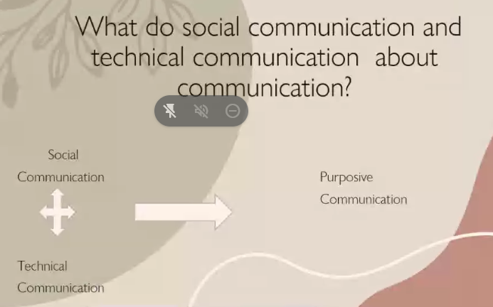

Purposive Communication is transactional communication. It involves social and technical communication. It is social in nature for it involves the interpersonal exchange of thoughts and ideas with common ends among people.

Purposive Communication is technical in form as certain predictable patterns are observed lending itself to the formal and professional manner of presenting issues f a business or industry - related environment.

**CONVEYING MESSAGES THROUGH WRITTEN COMMUNICATION**

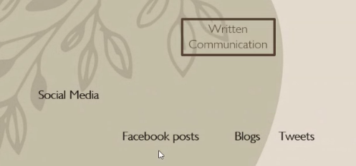

Social media, posts, blogs, chats, emails, videos, and other personal or individual technology- based forms of communication

Why Communication is important

We all use Communication and it help us what we are now Communication is at the root of what makes us human, and a core part of our society

communication **helps us build relationships by allowing us to share our experiences, and needs, and helps us connect to others**. It's the essence of life, allowing us to express feelings, pass on information and share thoughts. We all need to communicate

**Evaluating Messages**

**Messages**

Refer to any form of communication transmitted using a channel. The purpose is to inform, persuade or goodwill. It is important to think about what you want to say and how you want to say.

**TYPES OF TEXTS**

* Text types are general semantic - functional concepts and are not to be confused with

text forms.

1. **Narrative**-characterized by sequencing of events expressed using verbs and adverbs such as first, second, third and then.
2. **Descriptive texts** are concerned with the location of persons and things. They will tell us the background information.
3. **Directive** tangible are concerned with future activity. Central to these texts are the imperatives. Ex Hand me the book. Polite question-Would you like me to hand the bag?
4. **Expository** **texts** identify and characterize phenomena such as text forms such as definitions, clarifications, summaries and many types of essay. It may be subjective (essay) or objective (summary, explication, definition) or maybe analytical or synthetic (artificial)
5. **Argumentative** **texts** assumption that the receiver’s belief must be changed, often start with negation of a statement which attributes a quality or characteristic activity to something or someone. They advertising texts which try to persuade the readers.

**READING CRITICALLY**

* Critical reading in any involves scrutinizing (examine) any information that you hear or read. It is an active process of discovery.

**Requirements for Critical Thinking**

* ability to pose a question
* ability to analyze a problem on all its dimensions
* ability to find, gather and interpret facts and other information
* ability to imagine alternative solutions to the problem
* ability to analyze competing approaches and answers
* ability to write an effective argument justifying your choice

**Critical Reading Strategies**

* Previewing
* Contextualizing placing text in its historical, biographical and cultural context.
* Question to understand and remember
* Reflecting on challenges to your beliefs and values
* Outlining and Summarizing
* Evaluating an argument
* Comparing and contrasting related reading

**FOUR MAIN TYPES OF READING TECHNIQUES**

1. **SKIMMING** referred to a substance reading. It may help in order to know how what the text is about at its most basic.
2. **SCANNING** involves getting your eyes to quickly dart across sentence.
3. **INTENSIVE READING** it helps understand vocabulary words by deducing the words in a context. It help retention of information
4. **EXTENSIVE READING** involves reading for pleasure

**LISTENING CRITICALLY**

* Listening needs active participation. **Listening critically** involves evaluating and making judgments about what you hear.
* **Listening** is the active intellectual process of decoding, interpreting, understanding and evaluating messages. It is mode of communication as important.

**TYPES OF LISTENING**

1. **Critical** - listen for facts and supporting details to understand and evaluate details to understand the speaker's message.
2. **Emphatic** imagine yourself in the person's thinking.
3. **Appreciative** - identify and analyze aesthetic or artistic elements, such as characters development, rhyme, imagery and descriptive language.
4. **Reflective** - ask questions to get information and use or reflect on the speaker's responses to form new questions.

**How to evaluate your listening?**

1. Rephrase and repeat statements.
2. Compare and contrast interpretations
3. Research points of interests or Contention.

**COMMUNICATION AIDS AND STRATEGIES USING TOOLS AND TECHNOLOGY**

Teachers and students use **technology** as an avenue for learning.

1. **Printed Media** - considered one of the oldest forms of instructional media used in the classroom.
2. **Visual and Visual Media** - like pictures used to make communication interesting to the audiences. They help to convey the message more clearly and more appealing to the intended audience. Readers or listeners need to acquire visual literacy.
3. **Graphics, tables and charts** - visual representation of numerical data may be used to illustrate relationships among trends of data.
4. **Projected Visuals** - the most recent projected visual with the use of Liquid Crystal Display (LCD)
5. **Smart Television** - the most recent device used inside the classroom for audio - lingual presentation.
6. **DigitaI Audio** files comes in formats as wave, files and MPEG Layer 3 (mp3) files, other audio format are Windows Media Audio. Wma), Real Audio (ram or Musical Instrument Digital Interface. (MIDI)
7. **Video** is a series of images that when combined will form moving visual images. Youtube, Vodcasts
8. **Video Conferencing** - used to give lectures.
9. **E-mail**- send messages through mailing website.
10. **Multi-modal** **Texts**-can be paper as books. It can be digital from slide presentations

**COMMUNICATION THROUGH VARIOUS PURPOSES**

**TYPES OF SPEECHES**

1. **Expository /Informative Speech** an idea, speech- needs data to impart, explains an idea, a process.
2. **Persuasive Speech** it tries to convince audience to agree to a particular viewpoint.
3. **Entertaining Speech** - entertaining passages may be included.
4. **Extemporaneous Speech** - is an informal speech given to suit an occasion, event or audience and does not rely on a prepared manuscript.

**TIPS ON HOW TO PREPARE A SPEECH**

1. Gather valid proof from reliable resources.
2. Use appropriate appeals to support your arguments.
3. Present a clear outline.

**COMMUNICATING IDEAS EFFECTIVELY**

**Five Media Formats**

1. **Static** - the most common, simplest and easiest to format with the final design saved on an image file easy distribution online and to print on paper.
2. **Zooming** - used in for larger designs that convey a large amount of information with an added interactive layer for zooming controls for the readers to use.
3. **Animated** - creates some motion or change to the design as the reader watches ex .bars in a bar chart growing
4. **Video** - provide ease of sharing with the ability to be shared anywhere. Unlike static infographics, videos have the capacity to engage the audience more efficiently.
5. **Interactive** - designs give readers some control over

**Communication For Work Purposes the Nature of Workplace Communication**

Assume that the big circle in the middle is your near future. What would and where would you be? What would be the smaller circle represents?

**Workplace communication is best described as the process of transmitting ideas and thoughts**

Workplace communication, the process of exchanging information either verbally or non-verbal, is important in any social environment, including the academic structure and corporate environments

1. **Diversity in the workplace**

* Organizational culture the way an organization operates, the attitudes the employees have and the overall tone and approach.

1. **On worker Relationship** - TIME SPENT AT HOME FOR MANY IN THE ACTIVE EMPLOYMENT WORK PLACE. It is urgent then from a moment.
2. **Shared Leadership**- The distribution of leadership responsibilities within a team.
3. **Team Building**-where leadership is nurtured, teambuilding is not far behind. Formal and informal gatherings help build a strong team

**Team Roles Surface**

1. **Task roles**-role that help the team carry out tasks-information giver, developer
2. **Relationship Roles**-roles that strengthen or team relationhips: supporter, harmonizer
3. **Self-Centered Roles**- roles that interfere with the team’s ability to complete tasks: blocker, dominator, attacker

Nov 11 5-8 pm

make up class

**SPEECH**

**When Presenting SPEECH.**

1. Let your audience know important points by repeating key words and phrases.
2. Use verbal and non-verbal strategies. Vary the pitch of your voice and the rate at which you speak. Always remember, know your target audience. Speak the way they want you to speak. Talk at their level.

**FOR EVALUATING SPEECH**

Speaker introduce the topic clearly. The speaker support main ideas with appropriate details. Speaker establish eye contact. Speaker's gestures and movements reinforce the message.

* Speaker project loudly enough
* Speaker vary voice, pitch and speaking rate
* Speaker pronounce all words clearly and directly.

Topic: Obtaining, Providing and Disseminating Information

**The Process of Writing**

* **Prewriting** -includes exploring topics, choosing a topic and beginning to gather and organize details before you write.
* **Drafting**- involves getting your ideas down on paper. Serve as your blueprint, plan on how to execute your writing.
* **Revising**-rework your first draft, improve and review details in the content and structure
* **Editing ang Proofreading**- involves checking of your grammar spelling and mechanics.
* **Publishing and Presenting** stage wherein you share works to others and let them read yours.

**QUALITIES OF GOOD WRITING**

1. **Strong Ideas**- the starting point of any writing. Begin something that interest you and that will be your edge in writings.
2. **Organization**-present ideas and details in a consistent and organized manner.
3. **Voice** - referring to the sum total of your tone in writing. Includes use of words and construct sentences.
4. **Word Choice**- carefully chosen the words.
5. **Sentence Fluency**-read your work and identify which word is better. Use transition words ensure that you follow.
6. **Conventions** -ensure that you follow the convention of English grammar

**TYPES OF WRITING**

1. **EXPOSITORY** - expIains or inform a subject. Talk about without giving opinions.
2. **DESCRIPTIVE**
3. **PERSUASIVE**
4. **NARRATIVE**

**RUBRICS FOR THE MINUTES OF THE MEETING**

1. **ACCURACY**

* content is clearly factual leaving no room for doubts
* no editorial comments are evident
* the introduction, body and conclusion
* Correct word usage is observed.
* grammar is perfect.

1. **BREVITY**

* Brief and direct to the point
* Data given are essentials only

1. **CONCISENESS**

* a comprehensive and well-written memo is evident
* details are complete

**RUBRIC FOR THE MEMO**

1. **ACCURACY**

* Full details are provided leaving no room for doubts
* choice of words is appropriate
* grammar is perfect

1. **BREVITY**

* Brief and direct to the point
* Data given are essentials only

1. **CONCISENESS**

* a comprehensive and well-written memo is
* details are complete

Communication is not only limited to spoken words. Printed symbols commonly seen — billboards along the street, restaurant, advertisement and the like have an inherent power to convey ideas and to achieve a particular purpose.

Written communication is a valuable as oral communication.

**THE NATURE OF ACADEMIC WRITING**

“Exercise the writing muscle everyday, even if it only a letter, notes, a title list, a character sketch a journal entry. Writers are like dancers, athletes the muscles seize up."

**FEATURES OF ACADEMIC WRITING**

The texts abstract, literary analysis and political science paper are academic texts. Their content are structured to strictly adhere to conventions including but not limited to language choice, tone, style, pattern.

**COMMUNICATION FOR VARIOUS PURPOSES**

**Finding a Job**

1. Check out job search
2. Check out company websites
3. Check out your local government's employment resources
4. Visit Career Fairs

**Newspaper Classified Ads**

**Network**

Networking is a terrific way to find almost any job.

Friends, former teachers, relatives and professional contacts

**Characteristics of an effective job application**

**job application letter** or cover letter accompanies your resume when you are applying for a job. It should be specific

**Job application letter** or cover letter accompanies your resume when you are applying for a job. It should be specific to the position that you are applying for and demonstrate to the employer why, based on your background you are a great candidate for a particular position, based on the job description. Your **job application letter** to create a good impression on a potential employer

**According to work.chron.com the following are the things to consider in writing your cover letter;**

1. A specific start

Tell your reader that you want a particular job.

2.Explain yourself

3.Acknowledge Employer's Preferences

5.Professional Presentation

**QUALITIES OF A GOOD APPLICATION LETTER**

1. Complete

2. Simple and clear

3. Accurate

4.Relevant

5.Courteous and neat

**APPLICATION LETTER**

Essential Parts of a Job Application Letter

1. **HEADING** contains your full name . residentials address, landline and cellphone

Number, email address. Contact details must be updated.

CHRISTINE JOY C. HAGOS

No. 155 Magsipqg Streets

Bagong Barrio, Caloocan City, 1400 Philippines

Email gmail.cjhagos@gmail.com

Mobile: 0998-7654321

Tel: 336-555

1. **Date**

October 15,2022

15 October 2022

1. **Inside Address**

Contains the recipient's name, position, company and company address

Dir. Rosario V. Srquia

Director, Human Resources Department

ABS-CBN Corporation

1. **salutation**

Sir

Madam

Dear Sir

Dear Madam

1. **Greetings** like gesture of courtesy in your letter.

Greetings

Good day!

1. **Body** - contains the actual message

**Introductory Part**- draws the attention to your application' s reference and purpose

In response to your post at ___________

about your need of a smart and driven

individual to be a part of your team. I am

interested to fill up the position of

Researcher and be part of your team. I

am interested to fill up the position of

Researcher and be part of the globally

renowned and trusted media

conglomerate in the country, the ABS-CBN

Corporation.

1. **Complimentary Close** - closure of the letter

Very respectfully yours,

Very sincerely yours,

Truly yours, (less formal)

Cordially yours, (less formal)

1. **Signature Line** - basically your signature over printed name

Handwritten signature

Typewritten name

1. **Enclosures**

List documents attached with the letter.

**FORMAT OF THE APPLICATION LETTER**

1. **BLOCK FORMAT**-the most common format for a professional job application letter. The easiest format to set up.

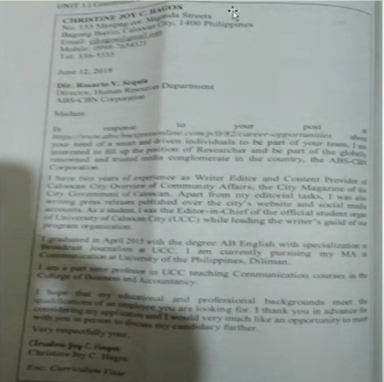

1. **Modified Block Format** - your name, address and the date are on the top right and the closing and your signature are on the bottom right. The employer's contact information and the remainder of the letter is left justified.

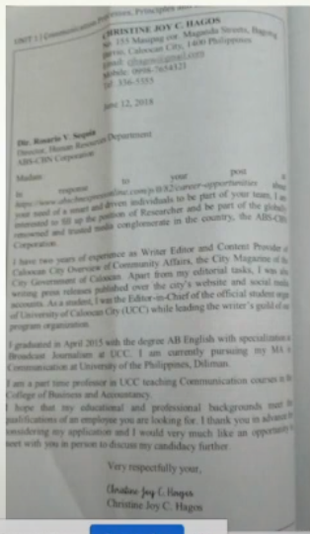

1. **Semi-BIock Format** - the most informal format

**PLANNING, WRITING AND COMPLETING YOUR RESUME**

**RESUME**

* IS A STRUCTURED SUMMARY OF A PERSON'S EDUCATION, EMPLOYMENT BACKGROUND AND JOB QUALIFICATION.
* THE PURPOSE OF A RESUME IS TO GET YOU FOR AN INTERVIEW.

**CURRICULUM VITAE (CV)**

* Referring to resume

1. **PLAN** 
   * Analyze the situation
   * Recognize that the purpose of your resume is to get an interview not to get a job.
2. **WRITE**
   * Adapt to your audience carefully
   * Plan your wording (education, experience into attributes that target employees find valuable.
3. **COMPLETE** 
   * Revise the message
   * Evaluate content and review readability.
   * Then edit and rewrite for conciseness and clarity

**Gather Information**

* Research target industries and companies

**COMPOSE THE MESSAGE**

* Write clearly, using active powerful language that is appropriate to the industries and companies that you target.

**PRODUCE THE MESSAGE**

* Use effective design elements and suitable layout for a clean, professional appearance.

**SELECT THE RIGHT MEDIUM**

* Start with traditional paper resume.

**Organize the Information**

* Choose an organizational model that highlights your strengths
* (Three steps writing process for Resumes by John Thill)

**THE FUNCTIONAL RESUME**

* "skills resume"
* Emphasize your skills and capabilities, identifying employers and academic experience.

**COMBINATION OR HYBRID RESUME**

* The combination or hybrid resume meshes the skills focus of the functional format with the job history focus of the chronological format

**ADDRESSING AREAS OF CONCERN**

* Frequent jobs changes
* Gaps in your work history
* Inexperience
* Over Qualification
* Long-term Employment with one company
* Job termination for a Cause
* Criminal Record

**WRITING YOUR RESUME**

**Four Points in Mind**

1. Treat your resume with the respect it deserves.
2. Give yourself plenty of time
3. Learn from good models.
4. Do not frustrated by the conflicting advice

**Sections of your Resume**

1. Name and Contact Information
2. Introduct0ry Statement

* Career Objective
* Qualifications Summary

1. Education
2. Work Experience, Skills and Accomplishments
3. Activities and Achieve
4. Personal Data and References

**RESEARCH-**the systematic investigation into and study of materials and sources in order to establish facts and reach conclusions**.**

Steps to follow in writing a research paper

1. Choose a research topic.
2. Narrow the topic.
3. Survey resources
4. Quote, paraphrase, a summarize.
5. Make an outline
6. Write the first draft.
7. reference

THE **TOPIC** IS THE MAIN SUBJECT OF YOUR PAPER. ONE MUST BE **INTERESTED**. a TOPIC RELEVANT AND THE AVAILABILITY OF MATERIAL RELATED TO IT IS IMPORTANT. Topics to avoid are topics on controversy.

1.Write down all possible topics that you think of.

2.Brainstorm with your classmates and friends

3.Conceptualize topics based on socially relevant issues.

4.Be updated on current events.

5.Ask suggestions from professionals.

**Narrowing down a researchtopic**

1.Ask yourself what you think about the topic or what you and what to say about it.

2.Determine your controlling idea or thesis statement.

3.Check whether it is suitable for authentic scholarly inquiry

**GATHERING MATERIALS**

**TYPES OF SOURCES**

1. **PRIMARY SOURCES** CONTAIN FIRST HAND INFORMATION ABOUT THE TOPIC AND PERSONAL VIEWS.

INTERVIEWS, AUTOBIOGRAPHIES, PHOTOGRAPHS, FILS, DIARIES

1. **SECONDARY SOURCES** THAT SERVE AS INTERPRETATION AND ANALYSIS OF PRIMARY SOURCES. THEY PROVIDE ELABORATION AND CLARIFICATIONS ABOUT THE MAIN SOURCES

SCHOLARLY JOURNALS BOOK, REVIEWS, ENCLYCLOPEDIA, EDITORIALS

**DOING LIBRARY RESEARCH**

THE LIBRARY IS AN IMPORTANT SPACE FOR LOCATING VALUABLE SOURCES BOTH **PRIMARY** AND **SECONDARY**. A LIBRARY IS A REPOSITORY OF SEVERAL TYPES OF DOCUMENTED INFORMATION.

**CLASSIFICATION SYSTEM**

* LIBRARY OF CONGRESS CLASSIFICATION (LCC)
* DEWEY DECIMAL SYSTEM (DOC)
* GET THE GENERAL INFORMATION FROM THE LIBRARY'S CARD CATALOGUE OR

ONLINE PUBLIC ACCESS CATALOG (OPAC)

* ONLINE RESOURCES

**Quoting**

**Plagiarism** is the act of stealing someone else’s work and presenting it as your own. when you fail to cite and acknowledge sources whether directly or indirectly.

**Direct quote** is used when you mention the exact words of an author in the research.

**Paraphrase** is the restatement of the author’s idea in the rsearcher’s own words without changing the meaning intended by the author

**Summary** is a restatement of the author’s main idea

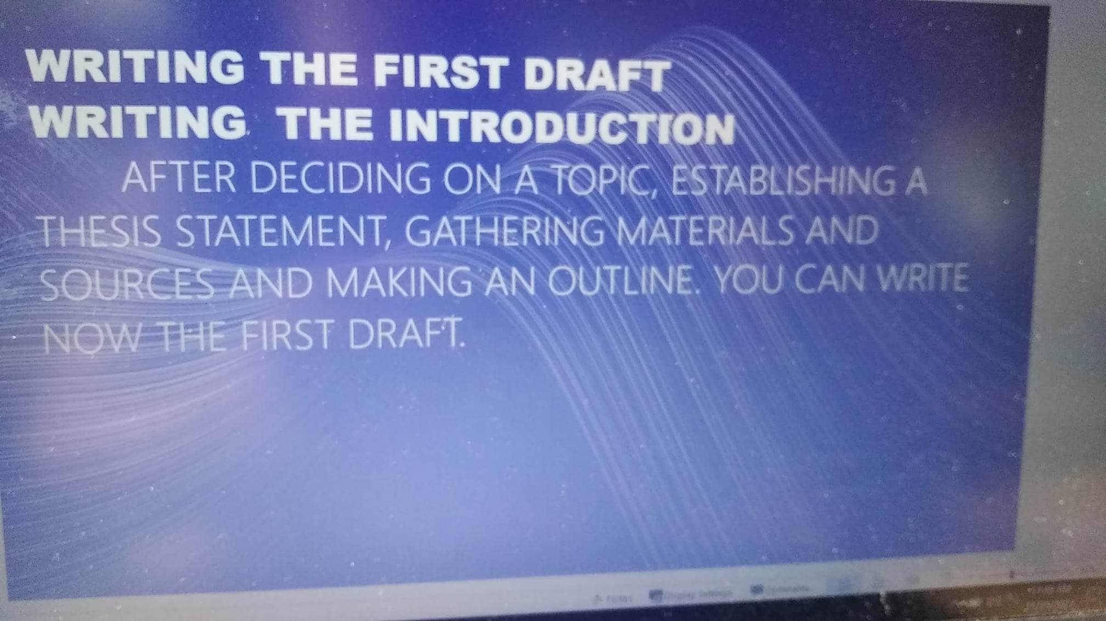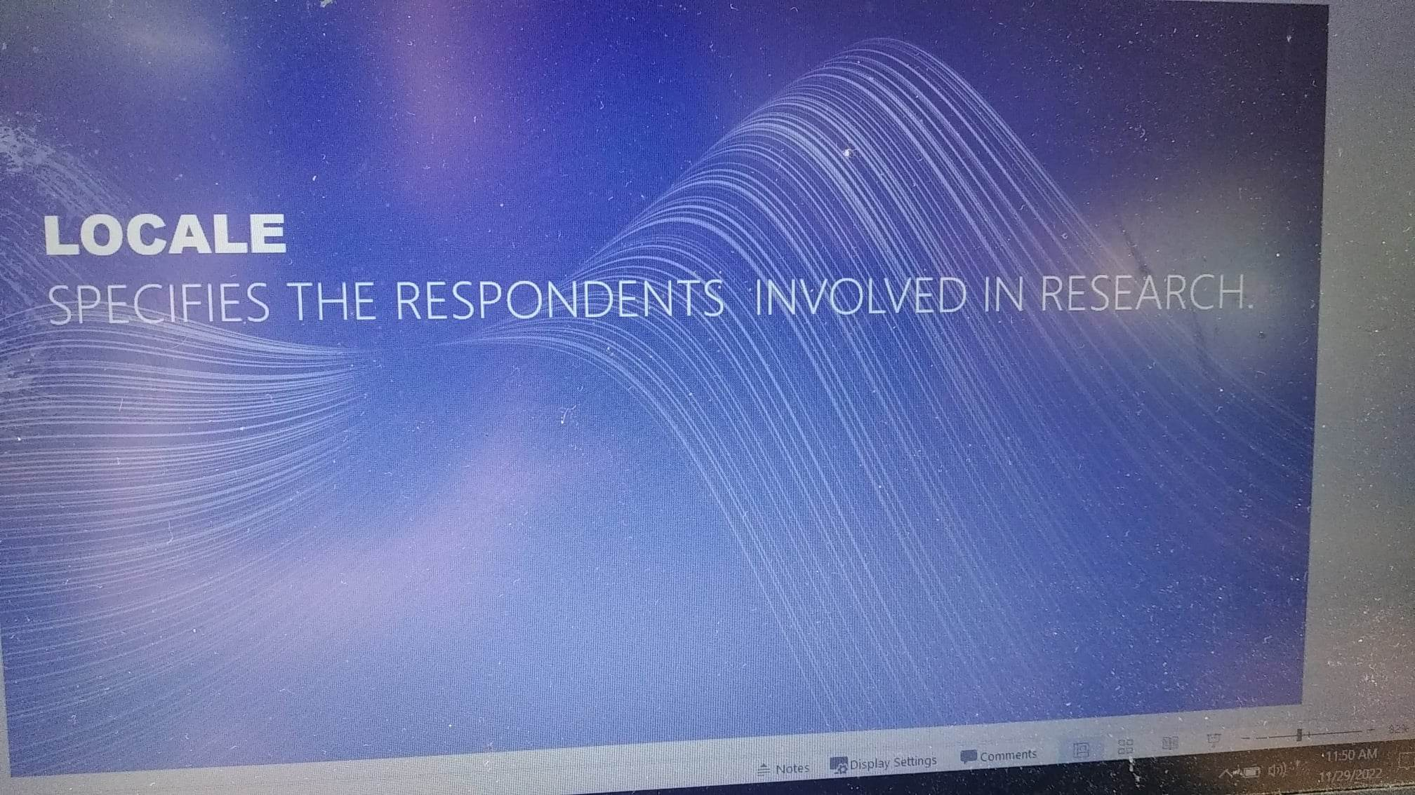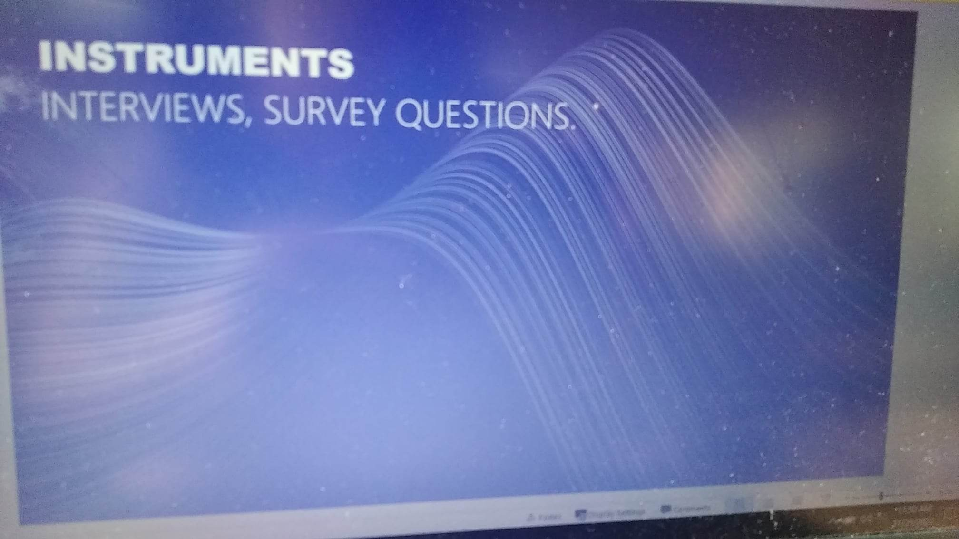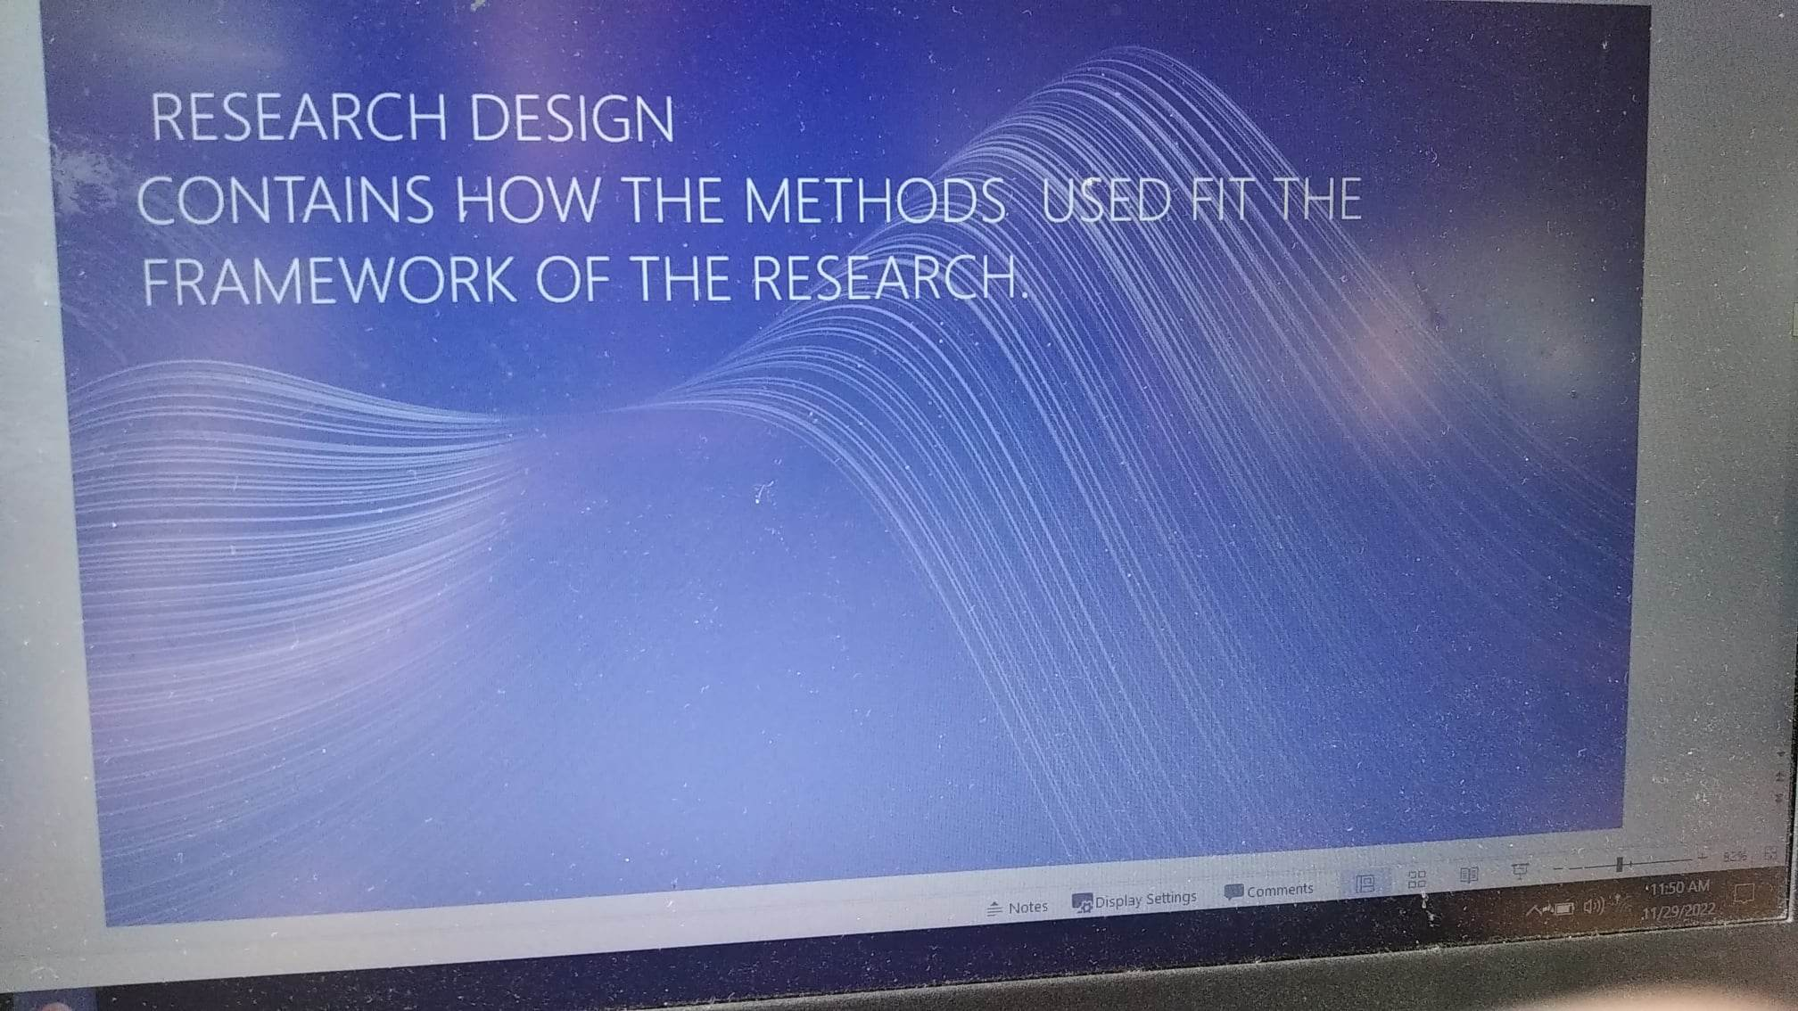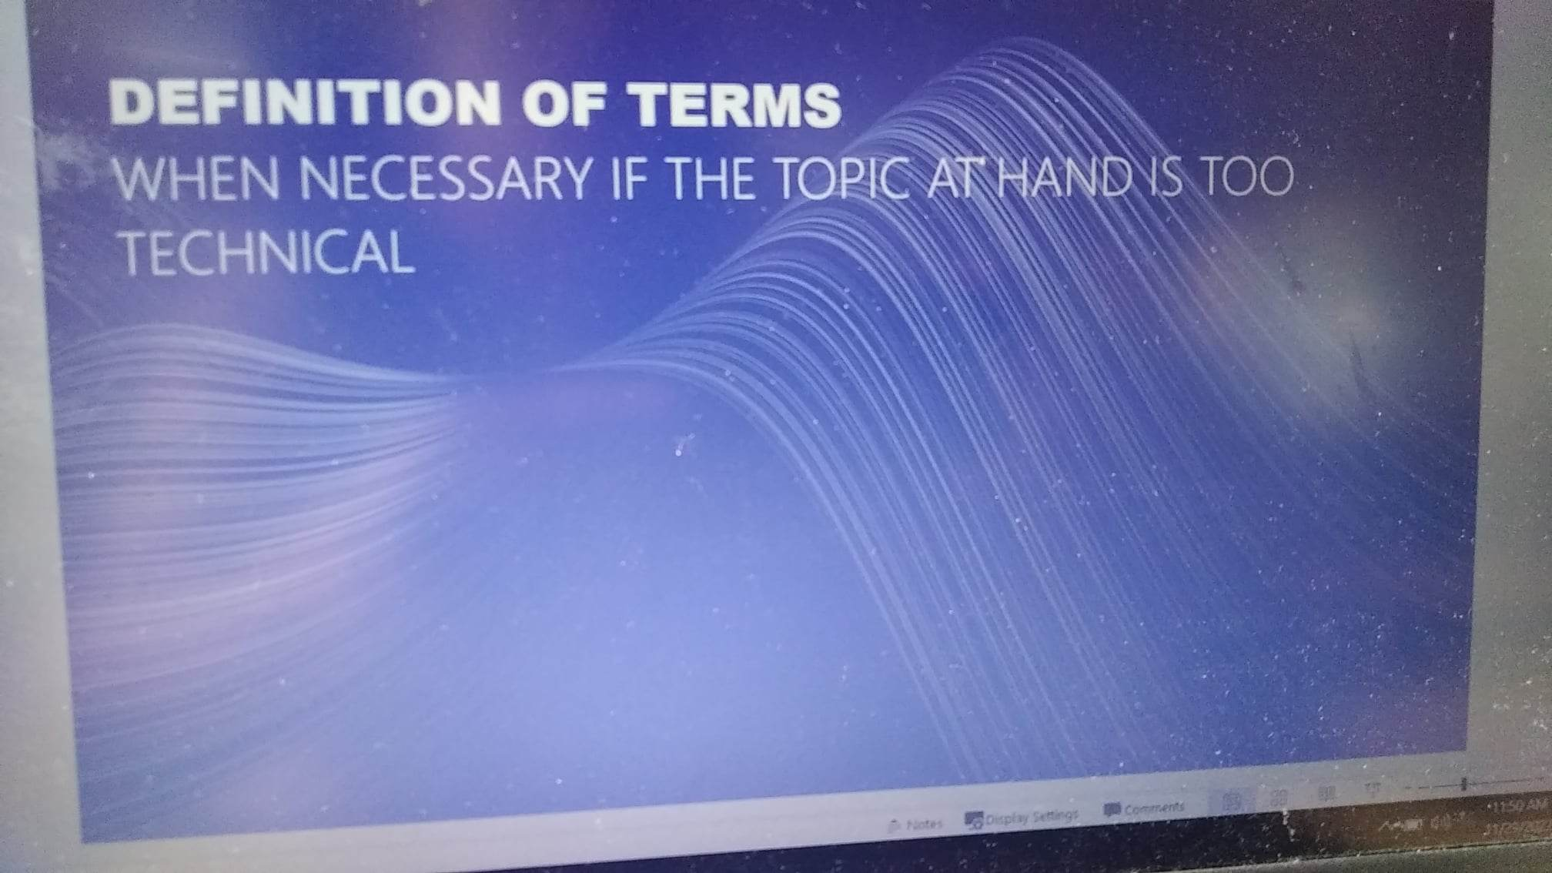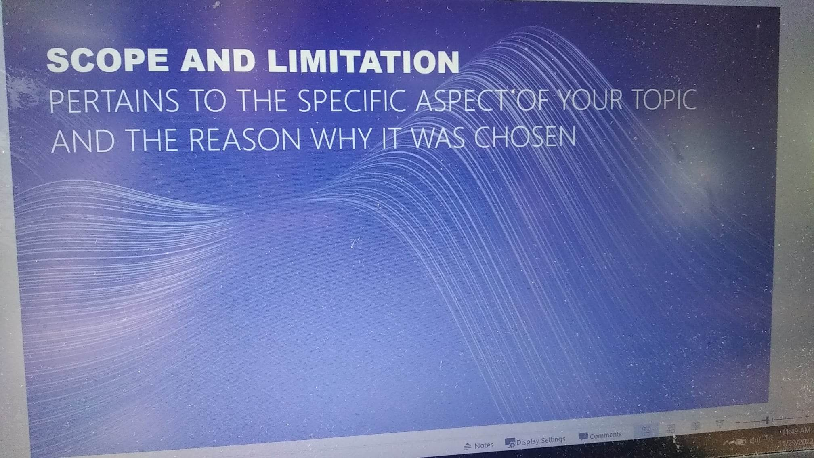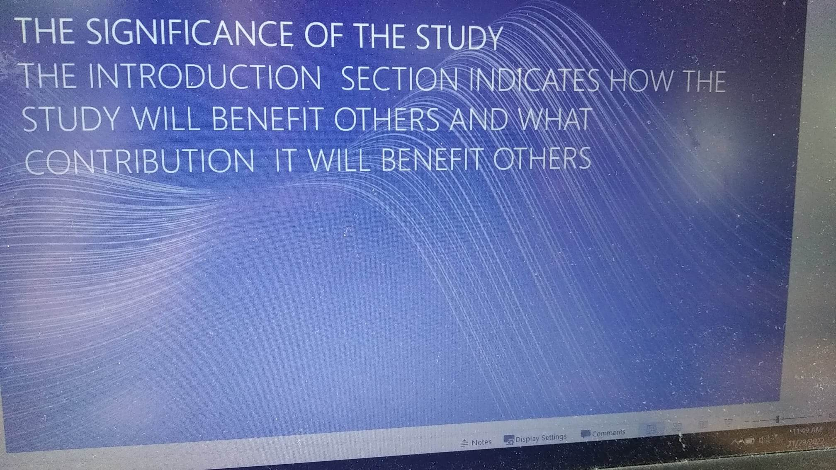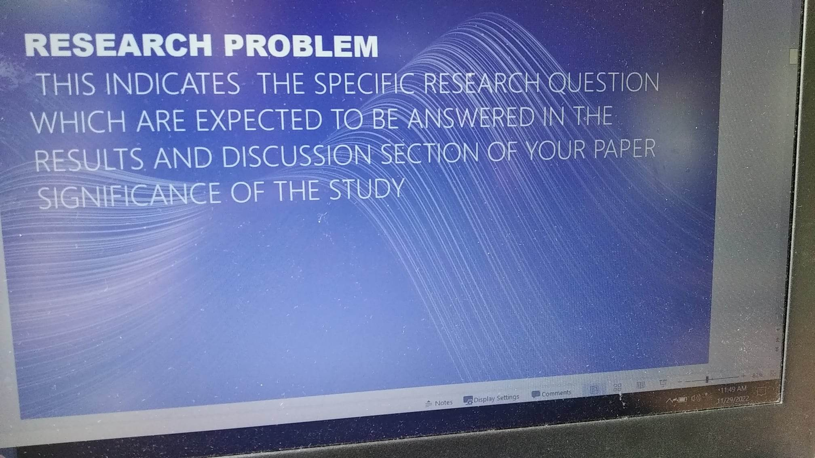

**SCIENTIFIC REPORTS**

* To write scientifically is to present information to common readers about basic sciences, drugs or medicines, technological innovation and practices which are published in medical news ,materials, academic journals and regulatory documents.
* Scientific writing targets greater public and makes them aware about science and technology of modern life and by relating these to the broader observable social problems.
* Ex. Health and safety
* **Medical writing** deals with conceptualizing clinical and scientific documentation in a standard, comprehensive , reliable, skilled and convincing manner.
* It is an art of writing about particular content more efficiently and clearly.
* A medical writer should be meticulous in analyzing, and developing every minute detail into therapeutic article.

**CASE STUDY**

* I t is both a method of analysis and research design for examining problems of a person, place, event or other type of analysis in order to extrapolate key issues.

**Field Reports**

* It is often prepared in the applied social sciences where there is a need to bridge relevancy.

JOURNALISTIC WRITING

* **JOURNALISM** is finding things out and telling about them. The process involves various skills with the purpose of getting people to read a story.

NEWS STORIES

* Stories about events, people and places. News should present both sides.
* It answers all the 5w’s and I h ( How )

HUMAN INTEREST STORIES

Person that has an emotional factor about a person

Editorials giving of opinions to a particular news.

RESEARCH STUDY

* PRIMARY AND SECONDARY SOURCES
* PRINT AND ONLINE SOURCES
* REFERENCE WORKS-gives general information. It is often consulted during preliminary research for overview and validation of the topic. It includes encyclopedia, dictionaries, almanac, bibliographies.
* GENERAL REFERENCE-are used for research paper information from variety of topics -History, sciences, arts, culture, tradition, politics, and geographical data. **Dictionaries** are helpful to find definition of terms. **Atlases** are used to find maps and geographical data. **Almanac** is consulted to statistical records and current events.
* SPECIALIZED REFERENCE- for in depth information about general topic. This is a great source of information . Authoritative bibliographies leads to a more specific references and literature. Periodicals such as journal magazines, thesis copies and other print materials comes with subcriptions
* FIELD REFERENCE- interviews, observations and questionnaires.
* INTERVIEW

**PROPER CITATION , DOCUMENTATION : AVOIDING PLAGIARISM**

**MODERN LANGUAGE ASSOCIATION ( MLA)**

Ex. Faigley, Lester .Fragments of Rationality . Postmodernity and the Subject Composition.Pittsburgh: U of Pittsburgh. 1992. Print

AMERICAN PSYCHOLOGICAL ASSOCIATION ( APA)

FaigleyL. ,( 1992). FRAGMENTS _____

**WRITING FOR ACADEMIC PURPOSE**  
**ABSTRACT**

* It is a brief summary of research paper with 100-200 words or shorter.
* It includes the main points of the research study , findings and results, conclusions and implications.

INFORMATIVE ABSTRACT

* Contains short description of the research paper , its methods , results and conclusions.
* **DESCRIPTIVE ABSTRACT** –shorter than informative.
* Provides less information.
* Provides a quick overview that invites the reader to read the whole text.
* **Proposal Abstract contains basic information**